LAB211 Assignment | Type: | Short Assignment
 | Code: | J1.S.P0008
 | LOC: | 50
 | Slot(s): | 1

Title
Letter and character count.
Background Context

Knowing the number of words or characters in a document can be important. For example, if the author is required to write a minimum or maximum amount of words for an article or paper, word counter can help them know if their article meets these requirements.

Program Specifications

Design a program that allows users to input the string value. Count and display the number of letters and characters

Expectation of User interface:

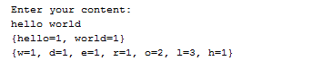

Guidelines
To tokenize a string, you can use StringTokenizer in java.util package

